# Lab-2 WAP using variables in PROLOG.

Write a Prolog program containing facts related to following predicates

a) Location (city, state)

b) Stays (person, city) in clauses section.

1. list of person, state and city.
2. Given person staying in which state.

Code:

domains

city,state,person=symbol

predicates

location(city,state)

stays(person,city)

rule(symbol,symbol)

clauses

stays(darshak,jamnagar).

stays(anjan,rajkot).

stays(ayushi,jamnagar).

stays(charmi,mumbai).

location(jamnagar,gujarat).

location(rajkot,gujarat).

location(mumbai,maharashtra).

rule(X,Z):-stays(X,Y),location(Y,Z).

Output:

1. list of person, state and city.

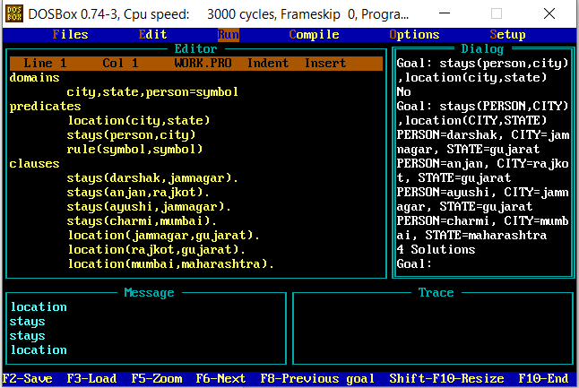

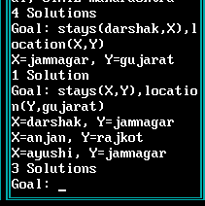

1. Given person staying in which state.

